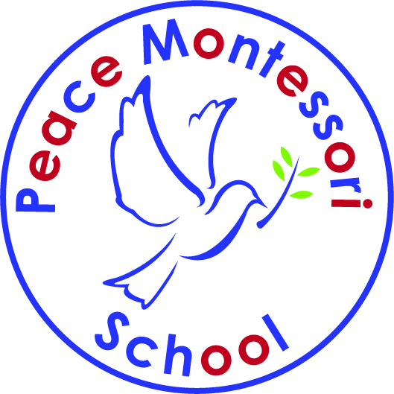
Peace Montessori School 2020-2021 Application
2190 N. Salem Street #103, Apex, NC 27523

There is a non-refundable application fee of $250 and a $300 deposit* required at the time of acceptance to the school. *Deposits are returned upon leaving the program with a 30-day notice. 10 Monthly Installments

Half- Day-Year/Month Full-Day-Year/Month

Toddler Class (Ages 2-3) 2 days ______$4499/$449 ______$5539/$543
Half-day 8:45-12:00
Full-day 8:45-2:45 3 days ______$5402/$540 ______$7203/$720

5 days ______$6911/$691 ______$8820/$882

Preschool Class (Ages 3-6) 2 days (T/Th) ______$4371/$437 ______$4987/$498
Half-day 8:30-12:00 or 8:45-12:15
Full-day 8:30-2:45 or 8:45-2:45 3 days (M/W/F)______$5334/$533 ______$6220/$622
5 days ______$6450/$645 ______$8325/$832

Kindergarten (Age 6) 5 days ______$8500/$850
8:30-2:45 or 8:45-2:45

Early 8:00am/Late 5:00pm ______$2940/294

Student Information:
Name: First Middle Last
Street Address City State Zip
_____Male _____Female Birth Date _________ Start Date _________
Parent Information:
Name: First Middle Last
Name: First Middle Last
Street Address City State Zip
Phone Number(s) Email for School Communications
How Did You Hear About Peace Montessori School?

Mailing Address: Peace Montessori School, 2190 N. Salem St., #103, Apex, NC 27523

Phone Number (919) 363-2461 www.peacemontessori@bellsouth.net

The undersigned hereby acknowledges that the information in this application is accurate in all respects.

Parent/Guardian Signatures/Date: _________________________________________________

